What is Database System? | DBMS – M01 P01

This is a multipart blog article series, in which I am going to explain you about the concepts of DBMS (Database Management System). This article series is divided into several modules and each module contains 10 parts.

In this article you will get to know that what database system is, and types of database system in detail.

Database System: Every organization whether private or government, have a big chunk of data and they have to maintain the data, in order to use it in future or for any other tasks like statics etc. To store this huge chunk of data every organization has their own database system. Database system are mainly divided into two categories “Database” and “DBMS”

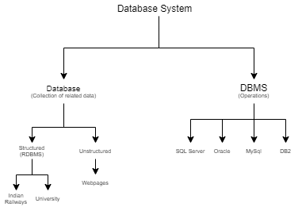

1. Database :- If I have to explain you the meaning of database in simplest manner then I will say that “database is a collection of related data”. Technically the database is future divided into three categories “Structured”, “Semi-structured” and “Unstructured.” We will discuss about structured and unstructured data because they are main and mostly concerned.

* Structured database: Structured database means that the database in which we can store data in a particular shape or structure. It is done with the help of a concept that is known as RDBMS (Related Database Management System). We store the structured data in the form of relation/table
  + Example : Database of Indian Railways.
* Unstructured Database: Unstructured database means that the database in which we do not store the data in any structured format.
  + Webpages, photos, videos.

1. DBMS :- Now as we had stored the data in a structured manner, then we also want to perform some operations on that data in order to use it, these operation can be “write”, “delete” or “update”. So, in order to perform these operations DBMS comes into play. DBMS provides us the way to manage the data by performing different types of operations on it.

* Different companies had made different- different DBMS the most common example of DBMS are “SQL Server”, “Oracle”, “MySql” and “DB2”.

***Note : At present almost 90% of the data is stored in unstructured form.***

This was an introduction to the topic DBMS, in which we had talked about database system and its different types.

If you have any doubt, query or question related to the above topic or if you want to share something with me, then please feel free to contact me.